**Experiment 39**

**Lab Book:**

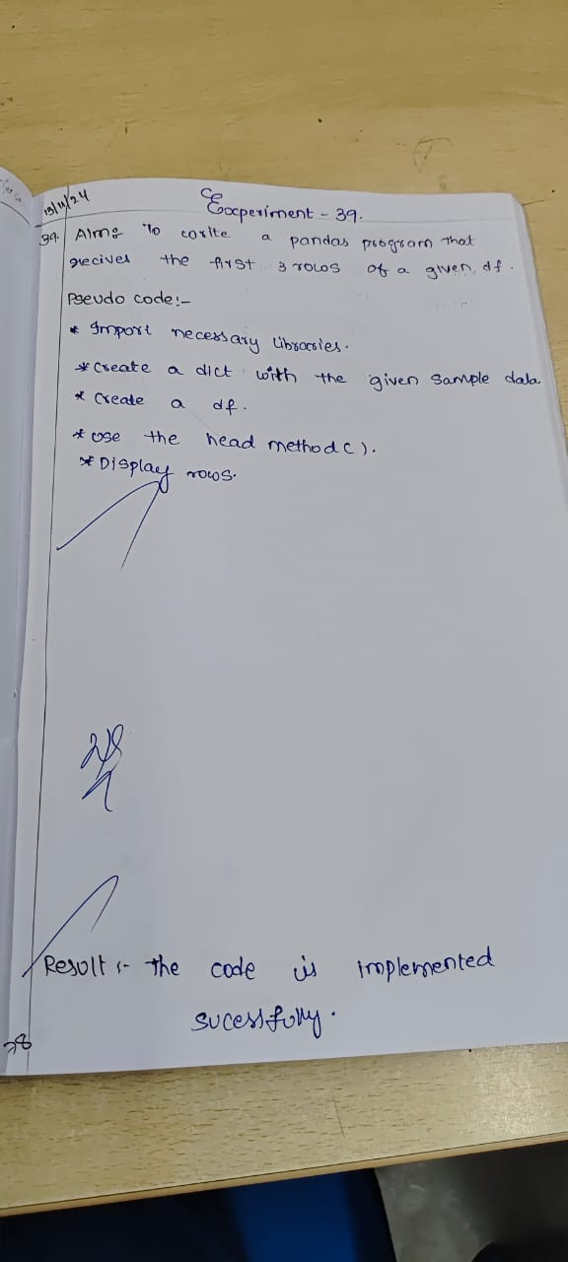

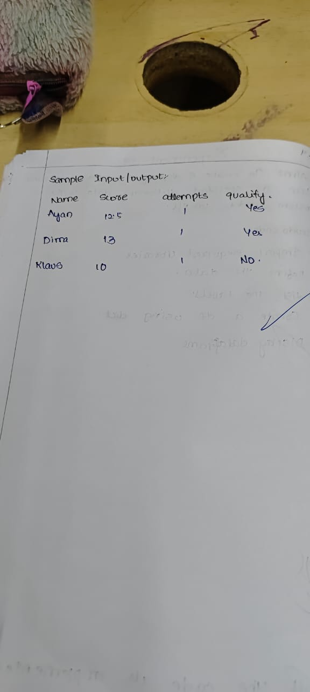

**Code**

import pandas as pd

import numpy as np

exam_data = {'name': ['Anastasia', 'Dima', 'Katherine', 'James', 'Emily', 'Michael', 'Matthew', 'Laura', 'Kevin', 'Jonas'],

'score': [12.5, 9, 16.5, np.nan, 9, 20, 14.5, np.nan, 8, 19],

'attempts': [1, 3, 2, 3, 2, 3, 1, 1, 2, 1],

'qualify': ['yes', 'no', 'yes', 'no', 'no', 'yes', 'yes', 'no', 'no', 'yes']}

labels = ['a', 'b', 'c', 'd', 'e', 'f', 'g', 'h', 'i', 'j']

df = pd.DataFrame(exam_data, index=labels)

result = df.head(3)

print(result)

**Sample Output**

